**Session: Introduction to Version Control**

**Name: Ahan Jain**

**EmpID: 8202**

**1. Git Setup** [**https://confluence.atlassian.com/bitbucket/set-up-git-744723531.html**](https://confluence.atlassian.com/bitbucket/set-up-git-744723531.html)

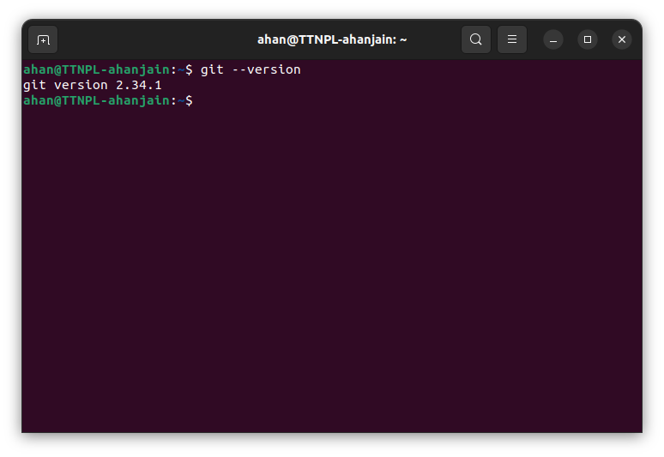

**2. Initialize a Git Repository**

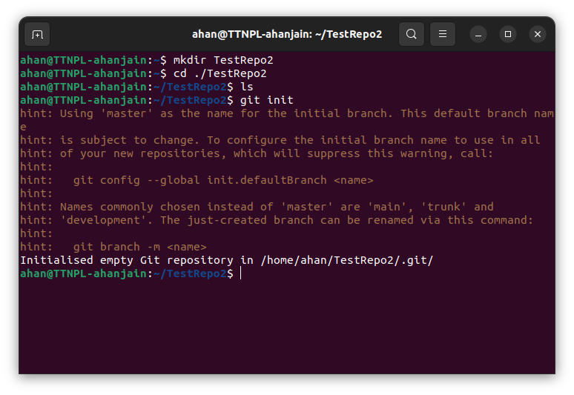

**3. Add files to the repository**

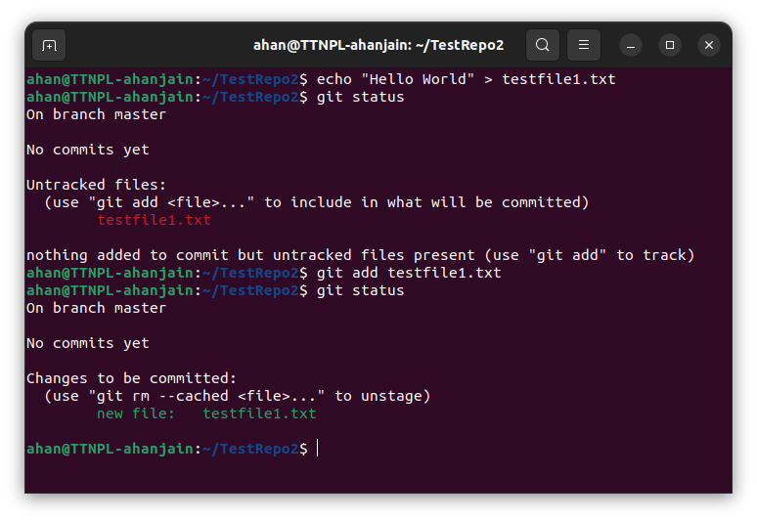

**4. Unstage 1 file**

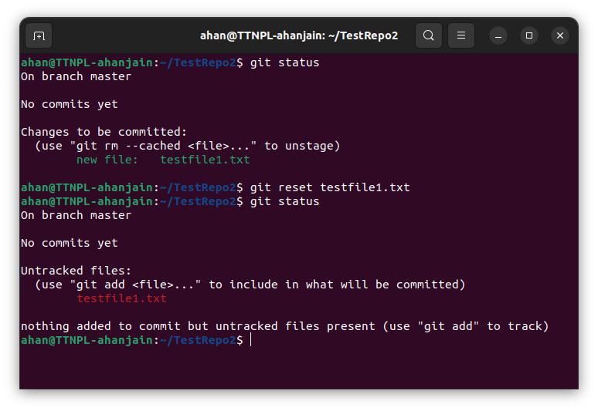

**5. Commit the file**

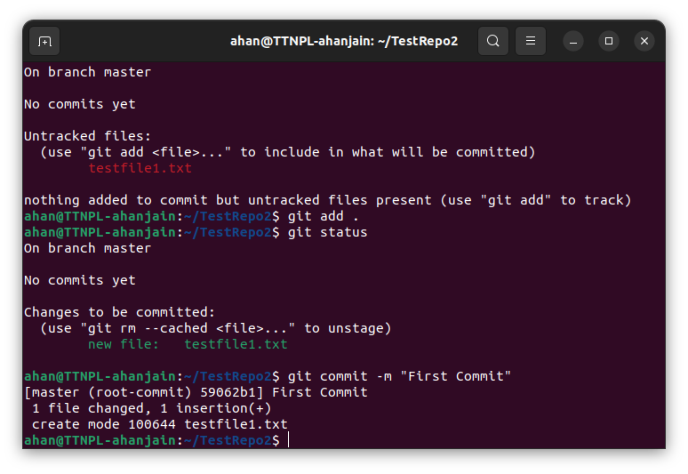

**6. Add a remote**

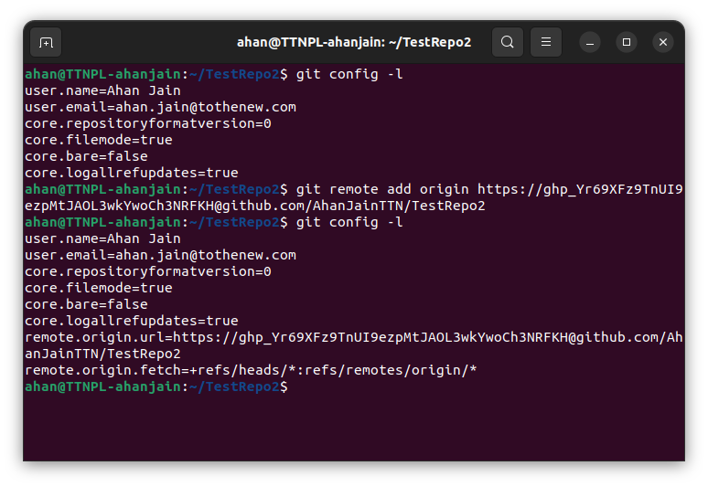

**7. Undo changes to a particular file**

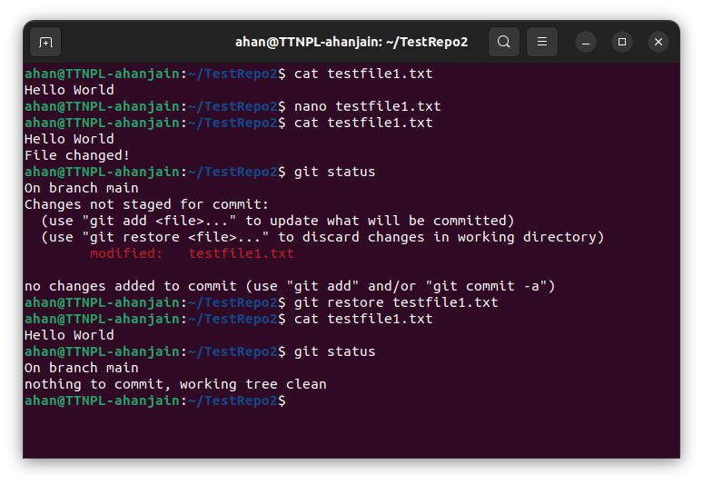

**8. Push changes to Github**

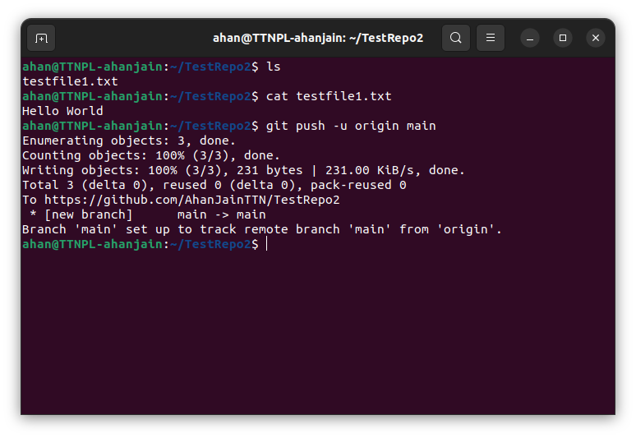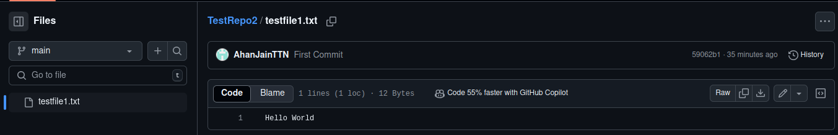

**9. Clone the repository**

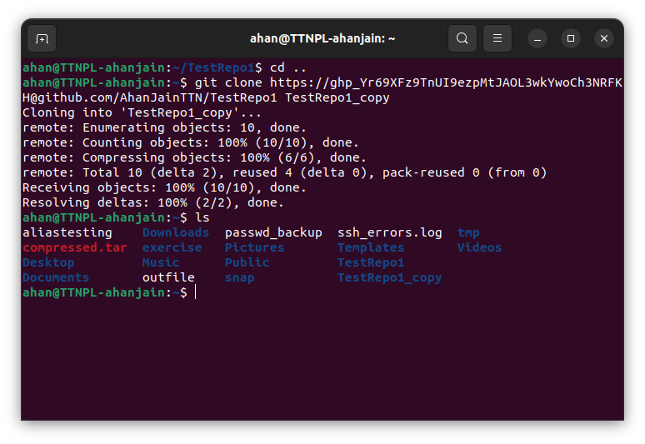

**10. Add changes to one of the copies and pull the changes in the other**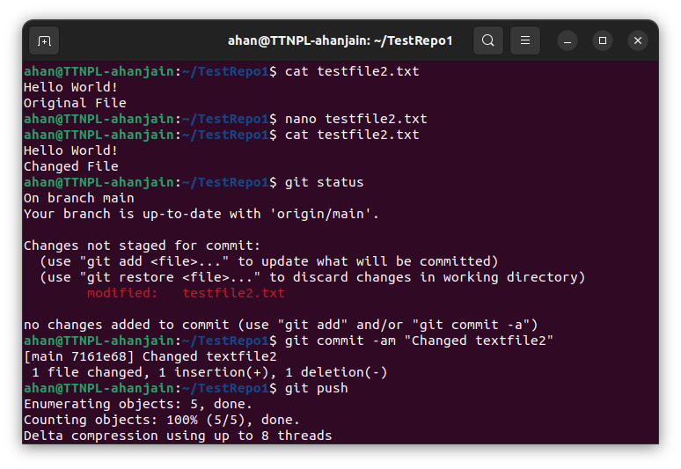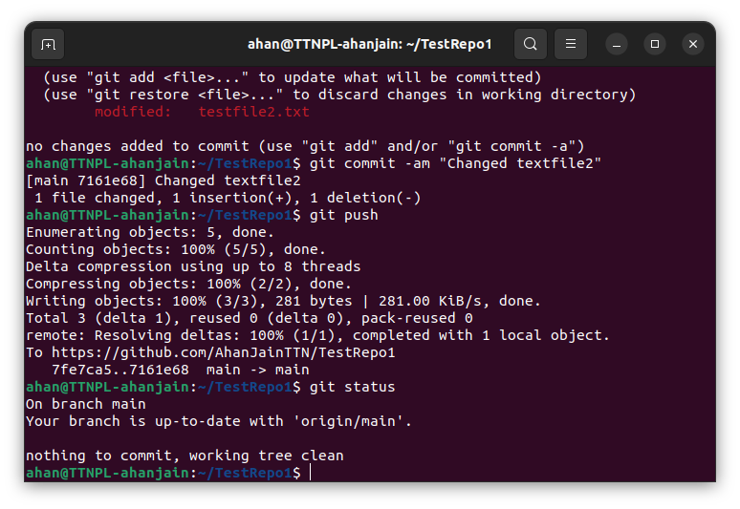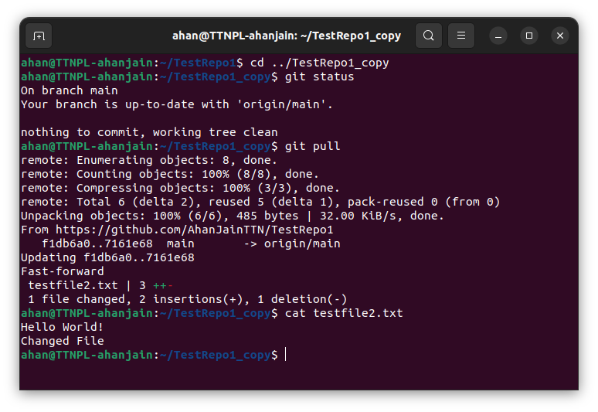

**11. Check differences between a file and its staged version**

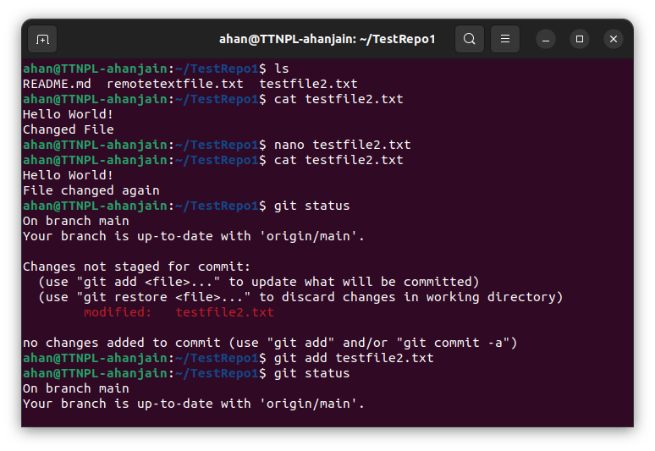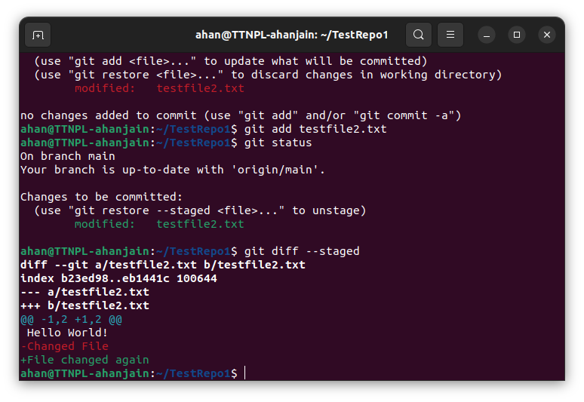

**12. Ignore a few files to be checked in**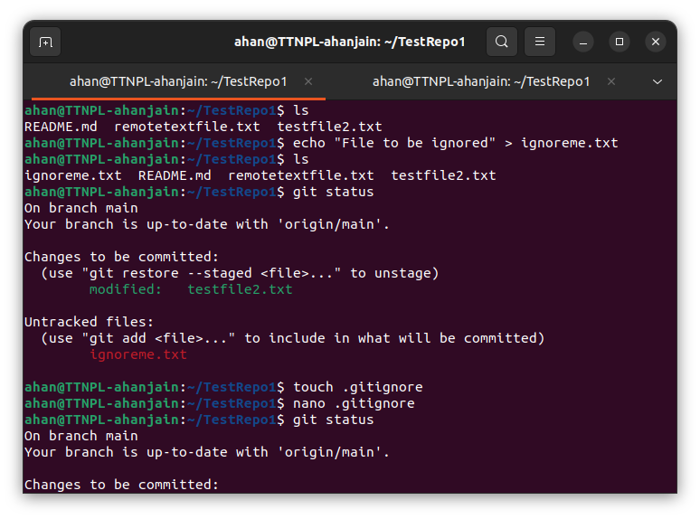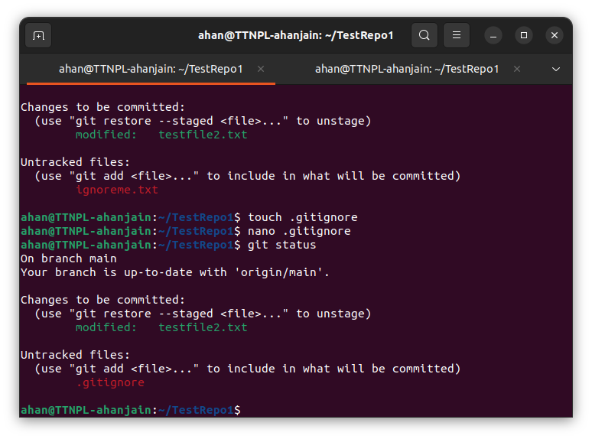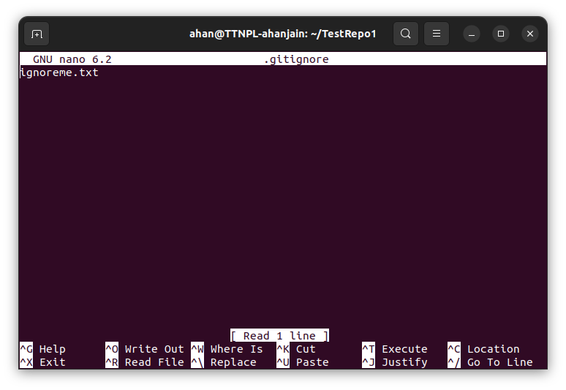

**13. Create a new branch**

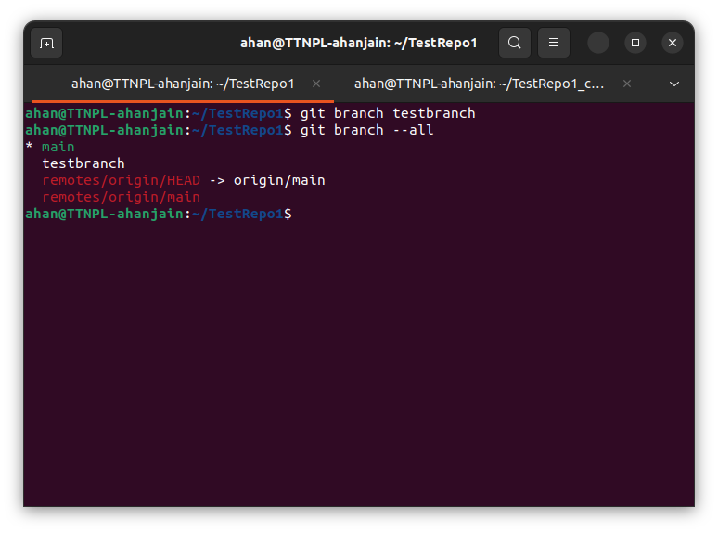

**14. Diverge them with commits**

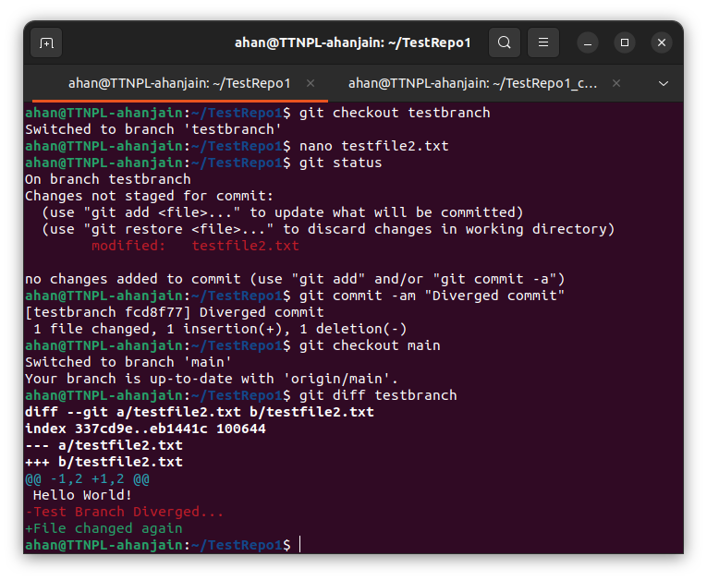

**15. Edit the same file at the same line on both branches and commit**

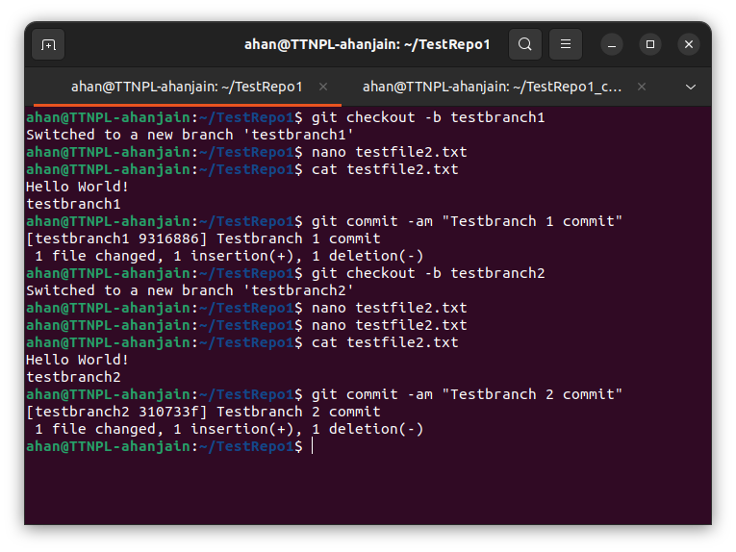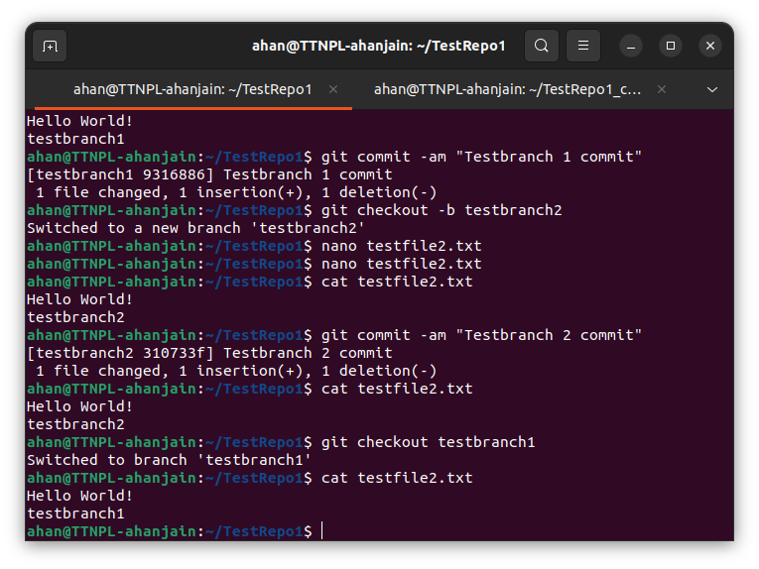

**16. Try merging and resolve merge conflicts**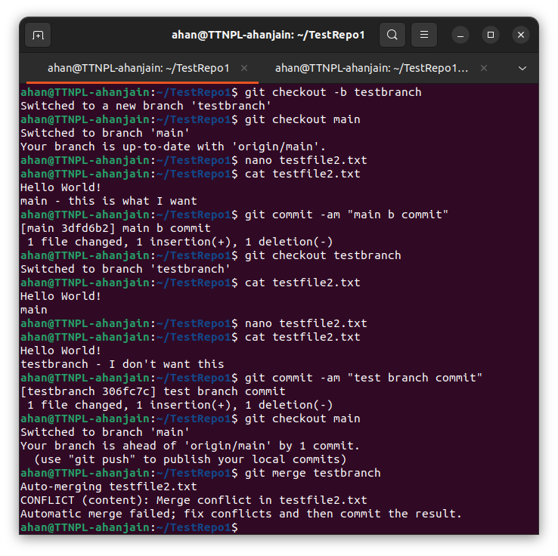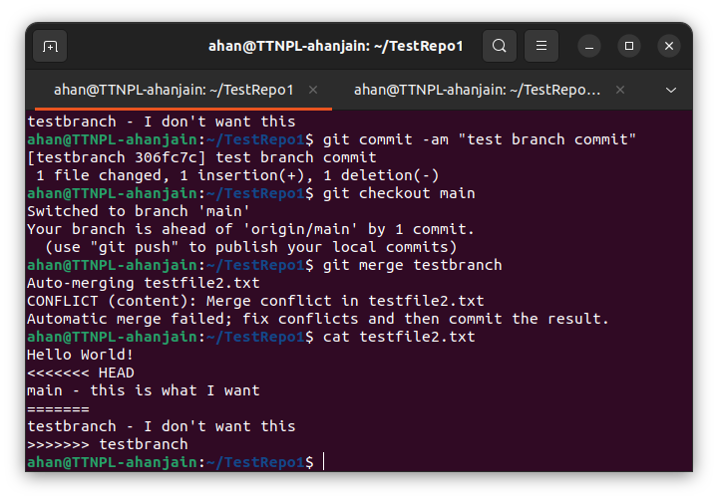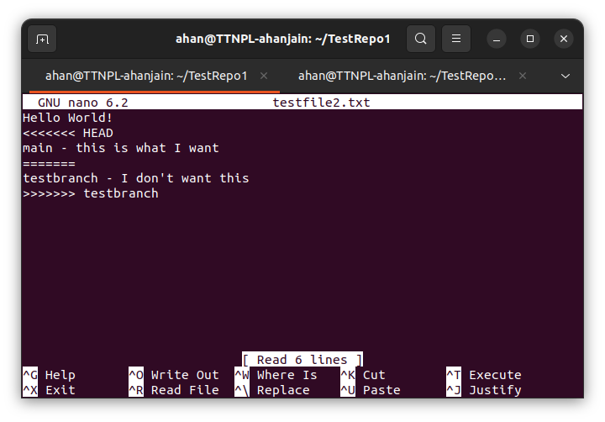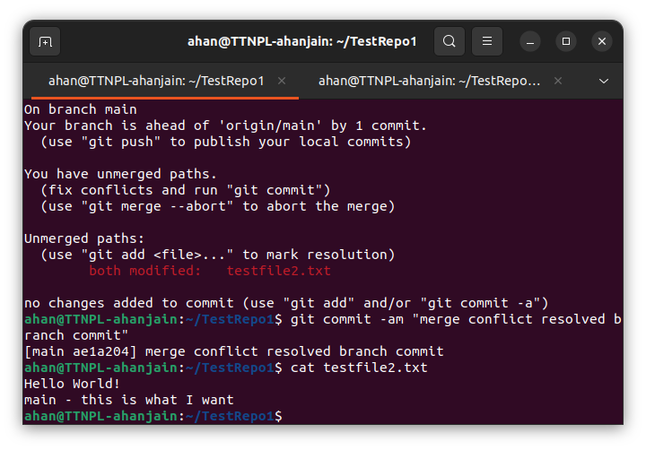

**17. Stash the changes and pop them**

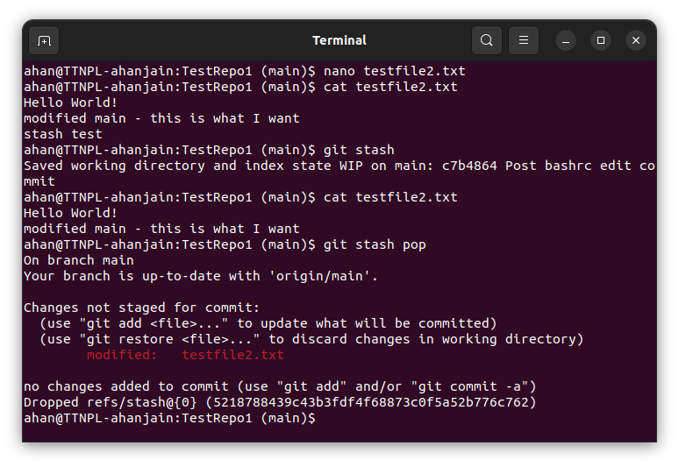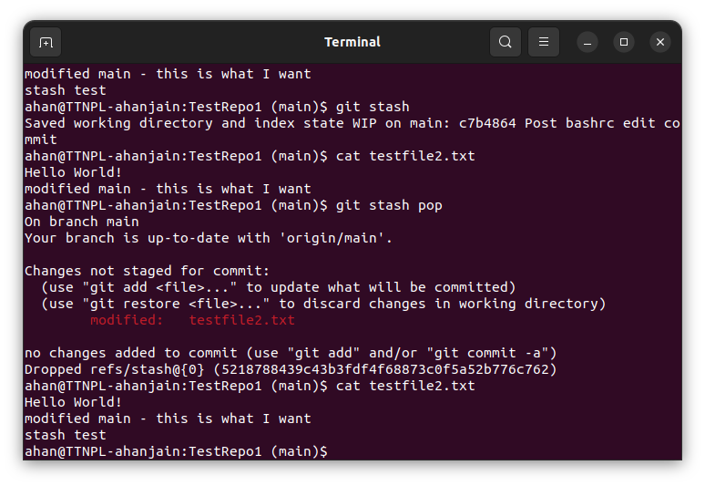

**18. Add the following code to your .bashrc file : color_prompt="yes" parse_git_branch() { git branch 2> /dev/null | sed -e '/^[^*]/d' -e 's/* \(.*\)/(\1)/' } if [ "$color_prompt" = yes ]; then PS1='\u@\h\[\033[00m\]:\[\033[01;34m\]\W\[\033[01;31m\] $(parse_git_branch)\[\033[00m\]\$ else PS1='\u@\h:\W $(parse_git_branch)\$ ' fi unset color_prompt force_color_prompt.**